Tutorial and Assembly Programme

Tutorial and Assembly Programme
Bacon’s College is a fully inclusive Church of England academy that is open to students of all faiths and none. Our Christian values, which are upheld by all members of the community, lie at the heart of our mission and ethos. They are: Courage, Compassion, Respect, Faith and Integrity.
Spiritual, Moral, Social and Cultural Development
Participation in collective worship offers opportunities to support the development of all our children in these areas, particularly Spiritual and Moral, through exploration of their personal responses to the Word of God and the teachings of Christ. Students learn to respect and listen to each other, and develop a better understanding of themselves, their local, national and global communities.
The Anglican Tradition
The whole community of faith come together each Monday morning in our main school hall facing the altar for whole school assembly; this includes the lighting of candles, opening prayers, a Bible reading and the College Prayer.
- Daily collective worship focuses on a modular theme and includes on a Bible passage, prayer and music.
- Each module is accompanied by a modular booklet with the ‘thought for the day’ and a PowerPoint for use by staff during assemblies or tutor group worship.
- We begin each day with a true sense of gathering in the name of God, Father, Son and Holy Spirit.
- We observe the seasonal cycle of the Church’s Year - Advent, Christmas, Lent and Easter, and special days such as All Souls and Palm Sunday are observed and celebrated.
- We also observe significant national events such as Remembrance, Holocaust Memorial
- Every observance aims to encourage whole school engagement but also allows time for personal reflection and growth.
- The Chapel is at the heart of our College and is available all the time for quiet prayer and reflection
- Using Anglican Liturgy such as Common Worship.
- Singing Christian hymns on key liturgical moments e.g. Carol service, Founders Day
- Experience Christian symbolism in worship and reflecting on their meanings e.g. cross, bread, wine, candle and liturgical colours.
- Using silence and reflection.
- Celebrating a weekly Eucharist.

Implementation
Collective worship is a legal requirement. In line with the statutory requirement, a Christian act of collective worship is provided for all pupils every day. All teachers attend all acts of collective worship. Time allocated to collective worship is not part of curriculum time.
Our current model, adopted to ensure compliance with Covid-19 measures, is as follows:
Key Stage 3

 | Year 7 | Year 8 |  |  | Year 9
Monday | Whole-College Assembly (virtual)
Tuesday | Assembly  (Sports Hall) | Mindful Minute  Whole-College Reading |  |  | Assembly  (Main Hall)
Wednesday | Mindful Minute  (Whole-College Reading) | Assembly  (Sports Hall) |  |  | Mindful Minute  (Whole-College Reading)
Thursday | Mindful Minute  (Whole-College Reading) | Mindful Minute  (Whole-College Reading) |  |  | Mindful Minute  (Whole-College Reading)
Friday | Prayerful Pause  Votes For Schools Tutorial | Prayerful Pause  Votes For Schools Tutorial |  |  | Prayerful Pause  Votes For Schools Tutorial
Key Stage 4

 | Year 10 |  | Year 11
Monday | Whole-College Assembly (virtual)
Tuesday | Mindful Minute  (Whole-College Reading) |  | Prayerful Pause  Votes For Schools Tutorial
Wednesday | Assembly  (Main Hall) |  | Mindful Minute  (Silent Reading/ Revision/ Admin)
Thursday | Mindful Minute  (Whole-College Reading) |  | Assembly  (Main Hall)
Friday | Prayerful Pause  Votes For Schools Tutorial |  | Mindful Minute  Numeracy Task  News and Current Affairs
Sixth Form
 | Year 12 |  |  | Year 13
Monday | Whole-College Assembly (virtual)
Tuesday | Tutor Period |  |  | Tutor Period/ UCAS
Wednesday | Tutor Period |  |  | Tutor Period/ UCAS
Thursday | Tutor Period |  |  | Tutor Period/ UCAS
Friday | Sixth Form Assembly  (Main Hall)

Teachers, year heads, senior managers and tutor groups lead collective worship on a rota basis, and pupils often lead tutor group worship.
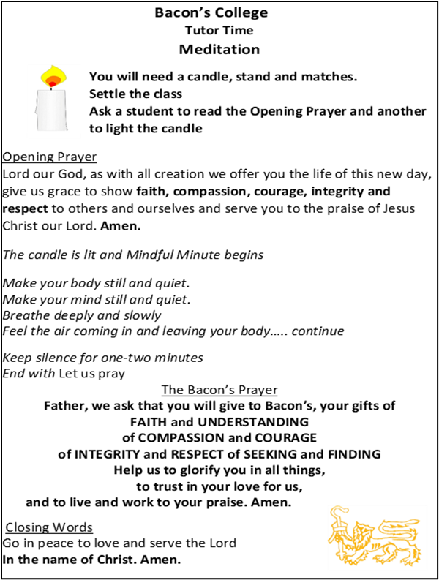

Resources
- Modular booklet which includes a Bible passage and prayer related to the modular theme and PowerPoints are available to guide and support worship, both collective and in tutor time.
- For new teachers to the school there is training explaining how to lead a tutor act of worship.
- Pupils are offered a variety of worship experiences, including music, prayer, silence, Bible readings and imagery.
Monitoring and Evaluation
- Fortnightly worship review meetings with the Vice Principal
- Regular monitoring of assemblies and tutor-based worship by SLT and Head of Year team – this includes feedback to tutor teams to ensure quality delivery
- Ongoing student/teacher feedback evaluated by Rev’d Nicky Teverson (Chaplain)

Right to Withdrawal
- We expect all students to attend the Acts of Worship. However, any parent can request permission for their child to be excused from religious worship, and the school will make alternative arrangements for the supervision of the student during that time. Parents do not have to explain or give reasons for their request.
- This right of withdrawal complies with the 1944 Education Act, and was restated in the 1988 Education Reform Act.
- The Principal keeps a record of all children who have been withdrawn from collective worship.
- Along with the parental right of withdrawal, teachers retain the right to withdrawal from collective worship. However, withdrawal by either children or adults is very rare. Those taking Acts of Worship make no assumptions about the beliefs of others.

