Science
Key Stage 4:  AQA |  |  |  |  | Key Stage 5:  AQA Biology/ AQA Chemistry/ OCR Physics
Year 7 | Year 8 |  | Year 9 | Year 10 |  | Year 11 | Year 12 |  | Year 13
4 lessons per week | 4 lessons per week |  | 5 lessons per week | 5 lessons per week* |  | 5 lessons per week* | 6 lessons per week** |  | 6 lessons per week**
* Students taking Triple Science will have an additional 2 periods of Science per week
** Biology, Chemistry and Physics at A-Level each have 6 periods of teaching per week
Staff |  | Role |  |  | Staff |  |  | Role
B. Patel |  | Curriculum Leader |  |  | J. Maybury |  |  | Teacher / Assistant Principal
T. Lijoka |  | Teacher / Head of Year |  |  | K. Anigiobi |  |  | Teacher/ College Rewards Co-ordinator
A Coles-Williams |  | Teacher / Assistant Curriculum leader |  |  | A. Coker |  |  | Teacher
S. Dervan |  | Teacher / Assistant Curriculum Leader (PE) |  |  | L. Lalero |  |  | Teacher
J. Wilson |  | Teacher/ Principal |  |  | A. Koroma |  |  | Teacher
J. Foley Jones |  | Teacher / Head of Sixth Form |  |  | K. Ingham-Roy |  |  | Intervention Group Teacher

Intent: what are we trying to achieve with our curriculum?
The purpose of the science curriculum is to develop children’s scientific understanding so they can be scientifically informed citizens and, if they wish, pursue careers in science, or in careers that require some scientific understanding. To be scientifically informed requires a broad knowledge of scientific ideas, an appreciation of how experimentation and observation develop this knowledge, and an ability to think rationally and analytically when applying this knowledge in new contexts. Practical work is included in the syllabus to allow students a hands-on opportunity to discover concepts, ideas and knowledge, as well as apply knowledge they have previously learnt.
The Bacon’s Science curriculum includes foundational topics in year 7 (e.g. Cells, Particles, Energy), which are required for further study in science. For example, ‘7CP Particles’ contains many elements that are necessary for accessing concepts found in later topics: diffusion; pressure; compounds, mixtures and elements. The year-to-year sequencing of topics is intended to reflect this progression of knowledge acquired being necessary to access further knowledge and that progression in science is defined by building knowledge on top of knowledge. Topics that have concepts that cut across different sciences are taught early, to allow students to appreciate the interconnectedness of many science disciplines. These concepts are then built upon at key stage 4 and, for those that choose to continue to their science studies, at AS and A-level.

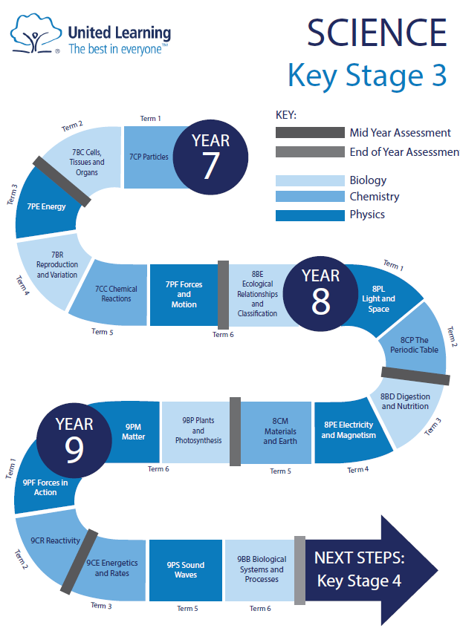

Implementation: how do we deliver our curriculum?
In our planning, we have asked ourselves 'why this, why now?’ In the science curriculum, we have several vertical concepts that appear in different units over the course of both Key Stage 3 and 4. A list of these can be found in Appendix A. Below we provide some examples of the curriculum choices we have made, based on these concepts, and why the units have been placed in the order we have chosen:
Example 1:
Year 7 starts with 7CP Particles, in which we introduce the concept of diffusion. We have placed this unit here as an understanding of particle behaviour is fundamental to all three sciences, and that movement in and out of cells requires an understanding of diffusion, which is taught in the next topic, 7BC Cells, Tissues and Organs. The idea is developed later in 9 PM Matter and will be revisited in a range of topics at Key Stage 4, including Organisation.
Example 2:
In 7PE Energy, we introduce the idea that energy is transferred between stores. This concept is applied in 8PE Electricity and Magnetism and developed further in Key Stage 4 in Energy, where energy is also quantified, using energy formulae. Energy is also linked to Forces via work done, which is introduced in 9PF Forces in Action, as well as Forces and Motion in Key Stage 4.
Example 3:
In Year 8, we introduce the Bohr model of the atom. This is an important part of the vertical concept, ‘reactions rearrange particles’, which begins in Year 7 with 7CC Chemical Reactions. The Bohr model is revisited in Atomic Structure and Periodic Table in Key Stage 4 chemistry, as well as Atomic Structure in physics, and is prerequisite knowledge for the next chemistry topic, Bonding, which in turn is foundational to many of the remaining chemistry units.
Example 4:
‘Forces affect motion’ is a fundamental idea in physics and is explored at length in Year 11 when Newton’s laws of motion are introduced formally for the first time. The fundamentals to this concept are first introduced in 7PF Forces, built upon in 9PF Forces in Action, before simple Newtonian mechanics are explored in depth in Forces and Motion in Year 11
Example 5:
In biology, the idea that ‘species show variation’ is central to understanding how organisms have evolved. This idea is introduced in Year 7 with 7BR Reproduction and Variation, with Darwinian natural selection introduced in Year 8, with 8BE Ecological Relationships & Classification. The genetic underpinning of variation is introduced in 9BB Biological Systems and Processes and developed further, alongside evolution and speciation in Key Stage 4 in Inheritance and Selection.

Teaching the Science Curriculum
Lessons in science do not follow a single template, as science can vary widely in the ideal approach. However, the following elements will be present over the course of a topic:
‘Do Now’ slides that review prior learning - this is usually in the form of a short, self-assessed quiz, but teachers are encouraged to adapt these to address or identify specific assessed gaps in learning. There are often slides following the ‘Do Now’ to cover essential prior knowledge, which teachers will need to use adaptively, depending on their class context.
Explanation guidance - where relevant, we have included guidance for teachers when explaining key concepts. It is not expected that teachers will routinely ‘click through’ these explanations, but they are provided to support less experienced teachers and non-specialist teachers.
Modelling – in many lessons, some slides provide models for teachers to exemplify best practice. In some cases (e.g., drawing a free body force diagram) the slides are provided to support teachers who are not confident in 'live' modelling using a whiteboard or visualiser. However, ideally, it is expected that teachers model these processes in 'real time' with students, using questioning to support and develop their construction. In writing, the resources contain model responses (WAGOLLS - What A Good One Looks Like) which exemplify a model of good writing for that concept (e.g. explaining natural section). As before, teachers are encouraged to use these to inform ‘live’ modelling of written responses as well as highlighting the features of good responses.
Guided practice – in many lessons there are specific slides to support guided practice, with prompts to support teachers in working through an activity after it has been modelled. This often includes the use of mini-whiteboards to check for understanding as practice is being guided. It may also involve showing how to use scaffolds to frame written work.
Scaffolds – where appropriate, examples of scaffolds have been provided to support student practice and structure their thinking. These include the provision of essential terminology to use in writing, tabular frameworks to help structure longer response writing and success criteria to inform self-review during a task.
Self/peer assessment – in all lessons, there is an emphasis on students assessing their own work. Where relevant, the key terminology, or features of a correct response are highlighted so that teachers can direct students explicitly to these during self/peer assessment.

GCSE Combined Science
 | Module 1 | Module 2 | Module 3 | Module 4 | Module 5 | Module 6
Year 7 | Particles  Cells and Digestion | Energy | Reproduction | Chemical Reactions | Forces | Ecology
Year 8 | Light and Space | Atoms and periodic table | Nutrition and digestion  Electricity and Magnetism | Materials and the Earth | Biological processes | Matter
Year 9 | Plants and photosynthesis  Matter | Reactivity  Forces in reaction | Sound  Energetics and rates | Cell Biology | Atomic structure and periodic table | Energy
Year 10 | Structure, bonding and properties  Organisation | Electricity  Infection  Chemical changes | Particle Model of Matter  Quantitative Chemistry | Bioenergetics  Energy changes  Atomic structure | Revision of all taught content | Ecology  Rates and equilibrium
Year 11 | Forces  Homeostasis  Chemical analysis | Inheritance  Rates and equilibrium Waves | Organic chemistry  Magnetism and electromagnetism  Inheritance | Chemistry of the atmosphere  Using resources | Review and Prepare | Public Examinations

GCSE Triple Science
 | Module 1 | Module 2 | Module 3 | Module 4 | Module 5 | Module 6
Year 10 | Organisation  Bonding, structure and properties  Electricity | Infection  Chemical changes  Particle model | Bioenergetics  Quantitative chemistry  Atomic structure | Energy changes  Rates of reaction  Forces  Homeostasis | Revision of all taught content | Organic chemistry  Waves  Ecology
Year 11 | Inheritance  Organic chemistry  Waves  Chemical Analysis | Ecology  Chemistry of the Atmosphere  Using Resources  Magnetism and Electromagnetism | Review and Prepare – revision of all taught materials and preparation for public examinations | Review and Prepare – revision of all taught materials and preparation for public examinations | Review and Prepare | Public Examinations

A-Level Biology
 | Module 1 | Module 2 | Module 3 | Module 4 | Module 5 | Module 6
Year 12 | Biological molecules,  Cell structure,  Transport across cell membranes | Nucleic acids,  Cell recognition and the immune system | Exchange,  DNA, Genes and protein synthesis | Mass transport,  Genetic diversity | Biodiversity,  Review & test preparation | Photosynthesis,  Respiration,
Year 13 | Energy & ecosystems,  Response to stimuli,  Nervous coordination and muscles | Homeostasis, Gene expression | Recombinant DNA technology,  Inherited change | Populations & evolution,  Populations in ecosystems | Review and test preparation

A-Level Chemistry
 | Module 1 | Module 2 | Module 3 | Module 4 | Module 5 | Module 6
Year 12 | Atomic structure  Amount of substance  Periodicity  Group 2 | Bonding  Chemical equilibria  Energetics  Kinetics  Group 7 | Redox  Kinetics  Introduction to organic chemistry  Alkanes  Alkenes | Halogenoalkanes  Alcohols  Organic analysis | Required practical consolidation and test preparation | Thermodynamics  Periodicity - period 3 elements
Year 13 | Electrode potentials and electrochemical cells  Kinetics  Nomenclature and carbonyl compounds  Aromatic chemistry | Equilibrium constant  Acids, bases, and buffers  Amines  Polymerisation | Transition metals  Reactions of inorganic compounds (aqueous solutions)  Organic synthesis  Amino acids | Structure determination  Chromatography  Test preparation | Test preparation

A-Level Physics
 | Module 1 | Module 2 | Module 3 | Module 4 | Module 5 | Module 6
Year 12 | Foundations of physics  Motion  Charge and current | Forces in action  Work, energy and Power  Energy, power and resistance | Materials  Electrical circuits  Waves 1 | Laws of motion and momentum  Waves 2  Quantum Physics | Review and test preparation | Capacitors
Year 13 | Thermal Physics  Ideal gases  Electric fields  Magnetic fields | Circular Motion  Oscillation  Particle physics | Gravitational fields  Stars  Radioactivity | Cosmology  Nuclear Physics  Medical imaging | Review and test preparation

In KS3, 4, and 5, Mid Unit Assessments are completed during all units, and constitute the assessed work for the topic. These generally follow the outline of long answer question (often 6 marks), working scientifically skills (4 marks). Where appropriate, students will be expected to produce extended response writing. Pupils then improve their work and self-assess a second piece of work against clear success criteria and with guidance from the classroom teacher. At Key stage 3 and 4 students also complete end of unit assessments, after which whole class feedback is given. In KS5, chapters are completed, assessed and reflected upon on a frequent basis using end of chapter assessments.
Impact: what difference is our curriculum making to pupils?
In KS3 & KS4 improvement can be seen from the initially completed (and teacher assessed) Mid and End of unit Assessments and the subsequently completed (and student self-assessed) assessments. These assessments also provide a valuable learning opportunity for students, allowing them to develop skills continually. Overall impact can be seen through achievement in end of cycle assessments during the year, culminating in UL wide end of year exams across the key stage 3 and 4, and external exams for year 11.
Implementation of these ideas has seen an improvement in GCSE Combined Science results of 11% from 2017/18 results to 2018/19 results and an 8% rise in students achieving 2 GCSE’s 4+. A-level results have seen achievement of ALPS 5 in Biology, ALPS 3 in chemistry, and ALPS 1 in Physics. A-level students have gone on to study science-based subjects at numerous universities including Cambridge University, Sheffield University, University of Bath, and University of Birmingham. In 2018-19 73% of students that studied A-level sciences went on to study Science at University.

Further Information and Guidance
GCSE Subject Information Sheet
Sixth Form Information Sheet

